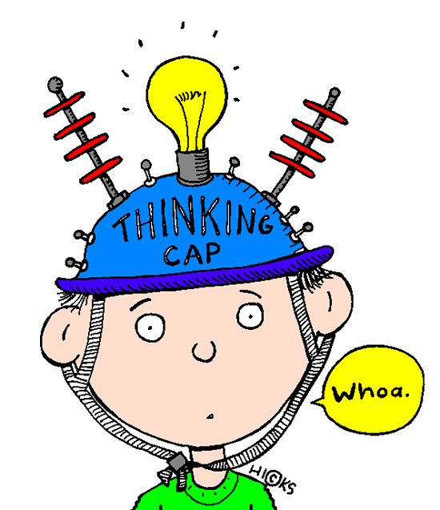
All about me!
At weekends we like to:
In my home the sports we like to play/watch are:
The festivals we celebrate in our home are:
On Sundays we:
The type of music we like to listen to/play is:
The languages we speak in our house are:

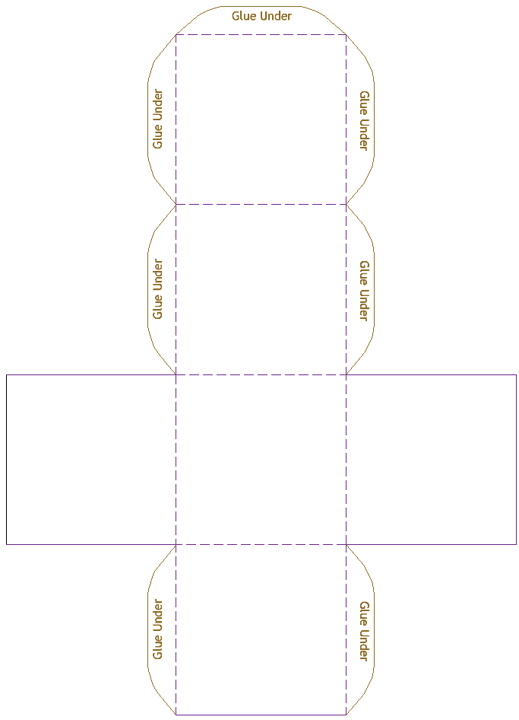
Lesson Three: Valuing the identity of self and others
Similarities and differences

Lesson Four: Fact or Opinion

FACT

OPINION
NOT SURE
Word Banks

Old People and Young People
Zimmer Frames | Skateboards | Hoodies
Wrinkly | Story Telling | Grumpy

Town People and Country People

Tractors | Sports Cars | Herding Cattle
Loud | Quiet | Cramped

Catholic and Protestant
Hurling | Rugby | St Patricks Day
The Twelfth of July | Chapel | Church

PDMU/CRED Lesson 6

Information on Musical Instrument Websites

The following websites may be useful for researching about musical instruments

http://www.drumdojo.com/lambeg.htm
www.celtic-instruments.com
http://www.ceolas.org/instruments/bodhran/history.shtml
http://www.oddmusic.com/gallery/

You may also want to add some more in of your own.

Lesson Seven: Understanding Conflict: Butter Battle Bubble Map
Grandpa
The narrator/the boy
VanItch
Daniel the Spaniel
The Chief Yookeroo
The Boys in the Back Room
The Butter Up Band
All of the Yooks

The Right-Side-Up Song Girls

Who was involved in the story?

All of the Zooks

Who was involved in the story?

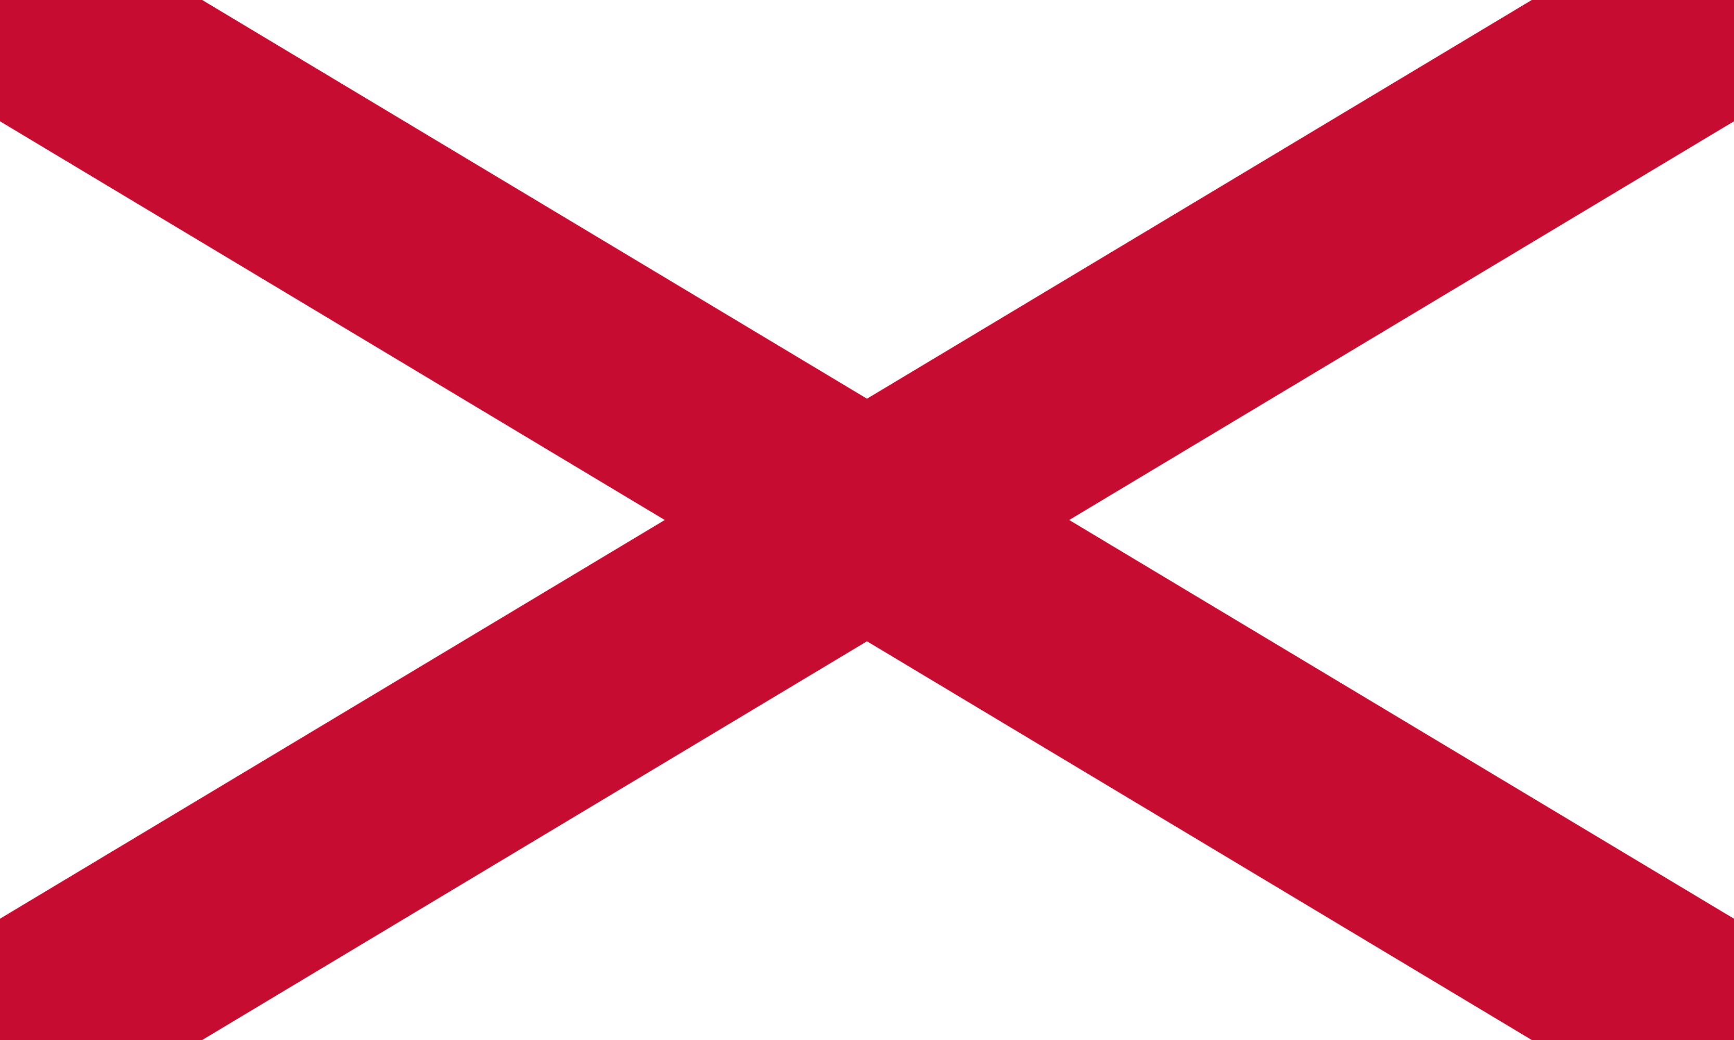
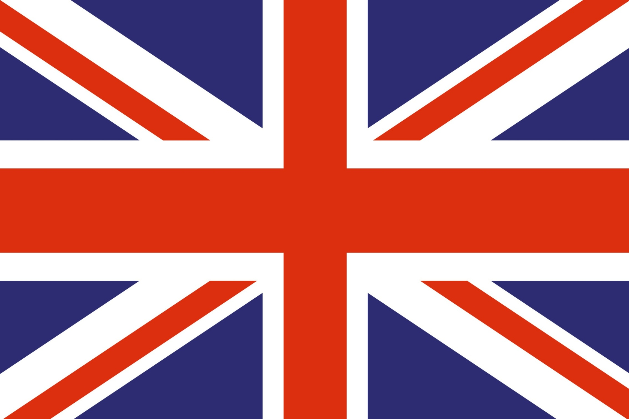
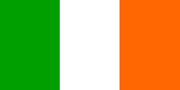
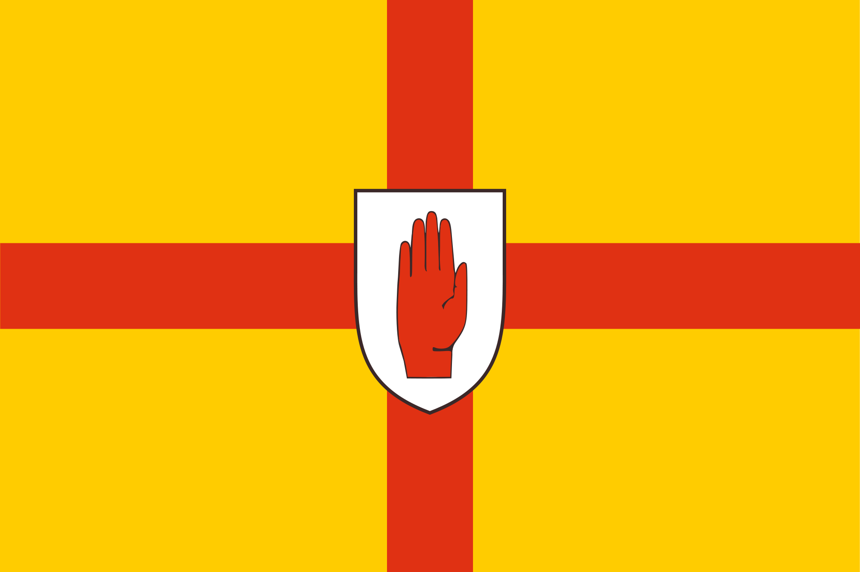
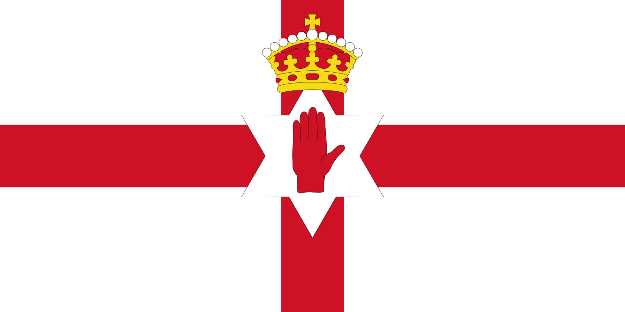
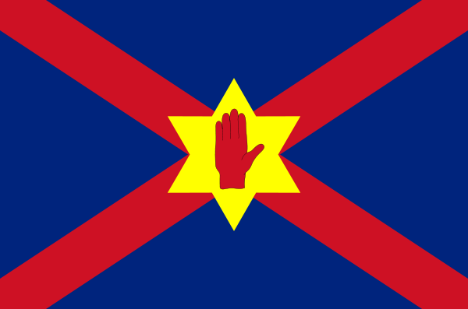
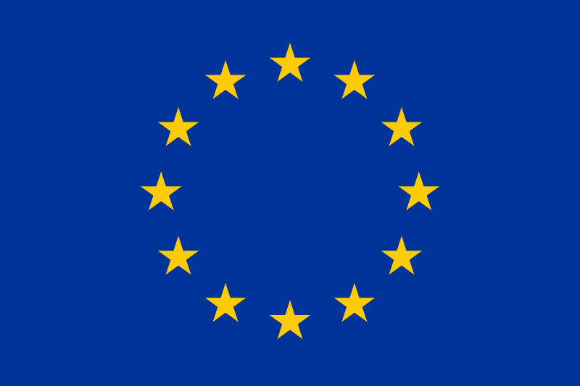
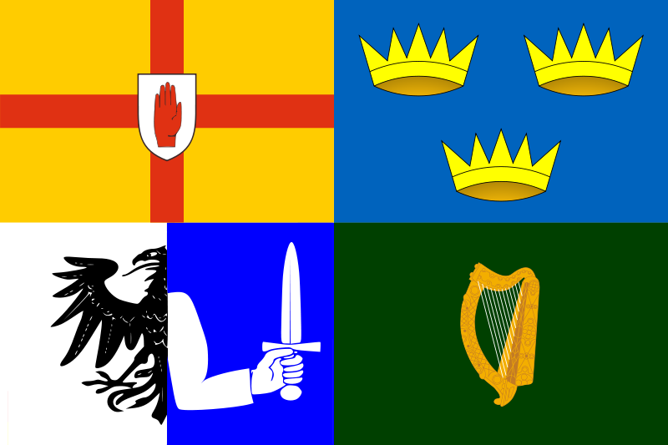
PDMU: Flag Worksheet
Name: _________________________________
Write down anything you know about the colours or shapes used in this flag
__________________________________________________________________________________________________________________________________________

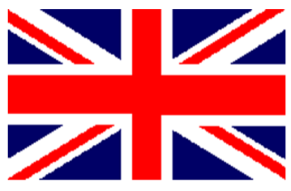
Name : _________________________________
Write down anything you know about the colours or shapes used in this flag
_____________________________________________________________________________________________________________________________________________

Name : _________________________________
Write down anything you know about the colours or shapes used in this flag
____________________________________________________________________________________________________________________________________________
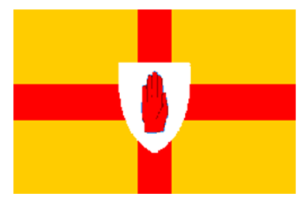
Name : _________________________________
Write down anything you know about the colours or shapes used in this flag
___________________________________________________________________________________________________________________________________________

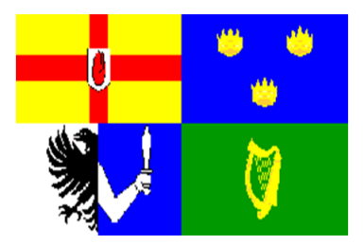
Name : _________________________________
Write down anything you know about the colours or shapes used in this flag
___________________________________________________________________________________________________________________________________________
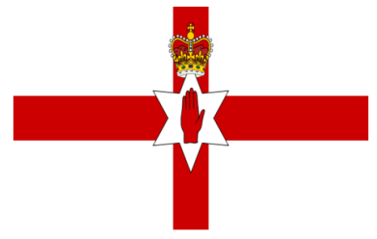
Name : _________________________________
Write down anything you know about the colours or shapes used in this flag
___________________________________________________________________________________________________________________________________________
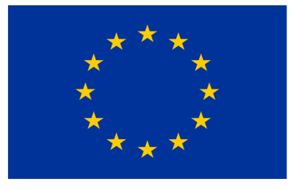

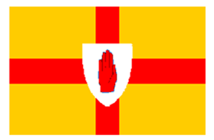 Name : _________________________________
Write down anything you know about the colours or shapes used in this flag
_______________________________________________________________________________________________________________________________

Flag Information Sheet

Flag | Information
Name: St Patrick’s Saltire or The Cross of St Patrick

Description: A red saltire (also described as a diagonal cross) on a white field.

The St Patrick’s Saltire is named after St Patrick, the patron saint of Ireland.
The red saltire from this flag appears as part of the Union Flag.
Name: The Union Flag

Description: The Union Flag brings together three flags:
- The Flag of England, also known as St George’s Cross: A red cross on a while background
- The Flag of Scotland, also known as St Andrew’s Cross: A white diagonal cross on a blue background
- The St Patrick’s Cross, representing Ireland: A red diagonal cross on a white background.
It uses the red cross of St George, the red saltire of St Patrick and the flag of Scotland to make the Union Flag. The design of the flag was made in 1801.

The Union Flag, is used to represent the United Kingdom of Great Britain and Northern Ireland.

The union flag is only called the ‘Union Jack’ when flown at sea.
Name: The Tricolour

Description: The Tricolour has three vertical bands of green, white and orange. The green band is where the flag is flown from. The colours in the flag are there for representation; green for the Catholic population and orange for the Protestant population of the island of Ireland. The white band in the middle represents the hope of lasting peace.

The Tricolour was originally designed to represent the whole of Ireland, but is currently used as the flag for the Republic of Ireland.

Name: The Flag of Ulster

Description: The Flag of Ulster has a gold background featuring a red cross with the symbol of the Red Hand of Ulster.
The flag is composed of two symbols which represent two ancient families from Ulster. The gold background and red cross came from the coat of arms of the Burkes and the Red Hand from the O’Neill family.

Legend has it that the symbol of the Red Hand comes from a race to conquer Ireland thousands of years ago. Heremon O’Neill racing a rival chieftain for possession of Ireland became the first man to touch its soil by cutting off his own hand and hurling it ashore!
His sacrifice made Heremon the first king of Ulster in 1015 B.C.

The Flag of Ulster is used to represent the province of Ulster, which is one of the four provinces of Ireland.
Name: The Four Provinces of Ireland

Description: Each flag from the four provinces of Ireland are brought together to form the one flag. The four provinces are known as Ulster, Munster, Leinster and Connact. Top left is Ulster, top right is Munster, bottom left is Connact and bottom right is Leinster.
Name: The Ulster Banner

Description: The Ulster Banner is composed of a red cross on a white field, the Red Hand of Ulster on a six pointed star and a crown at the top of the star.

It is based on the English Flag and the Flag of Ulster with the addition of the six pointed star to represent the six counties of Northern Ireland and the crown on top for the British Monarchy.

It was formerly the flag for the Government of Northern Ireland, but it no longer has any status. It is sometimes used at sporting events to represent Northern Ireland.
Name: The Flag of Europe

Description: The European flag has a background of Azure blue with twelve, five pointed golden stars formed into a circle.

It is used to represent the council of Europe and the European Union. The number of stars is based on the fact that twelve is seen as a symbol of perfection and completeness, and does not represent the number of countries in the European Union.
Lesson Nine: Symbols in Northern Ireland
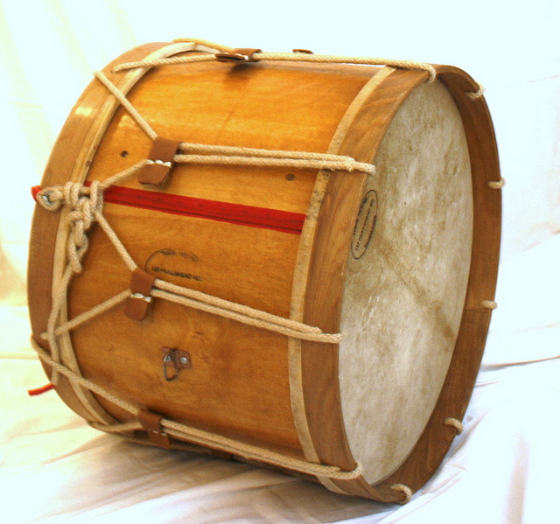
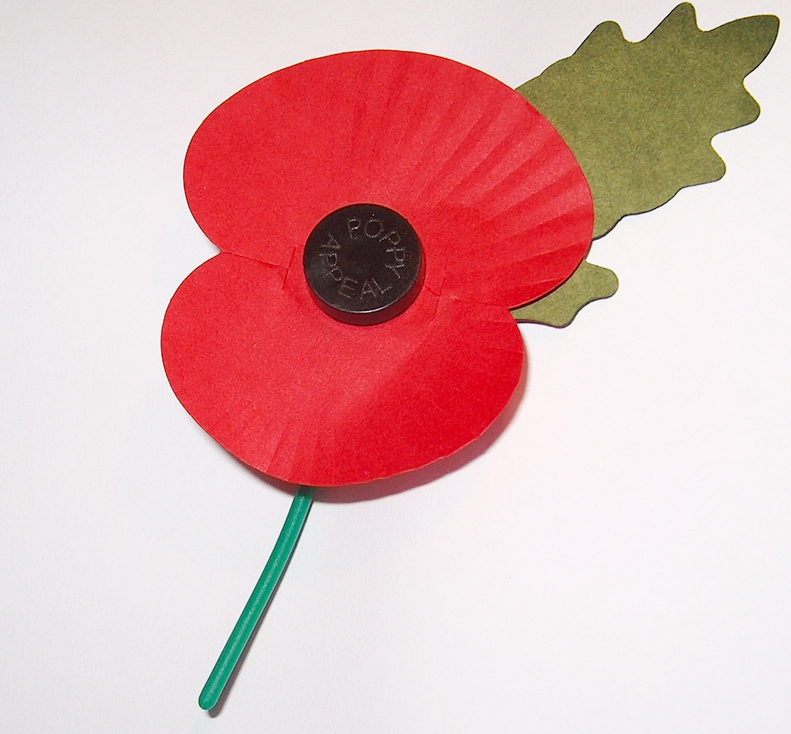
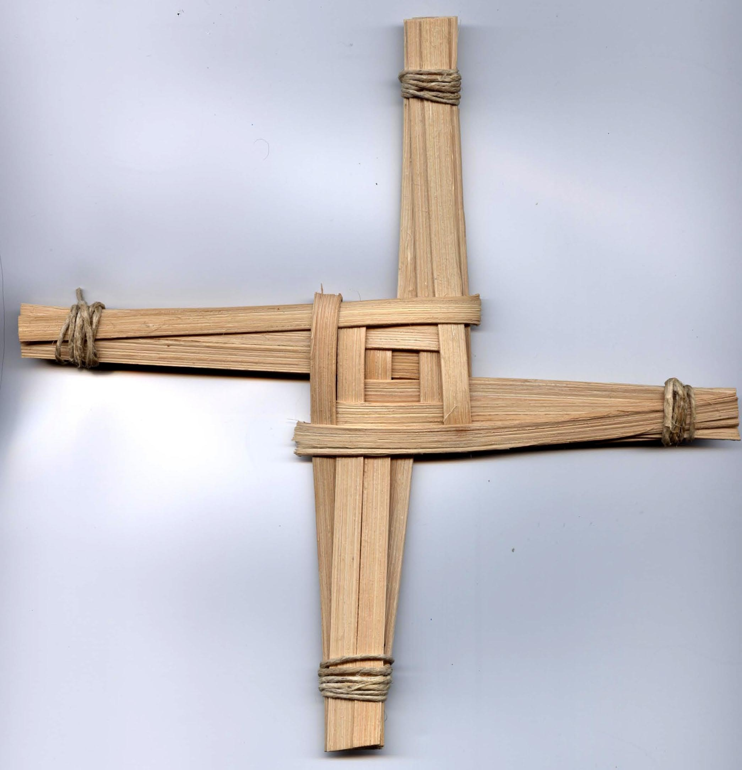
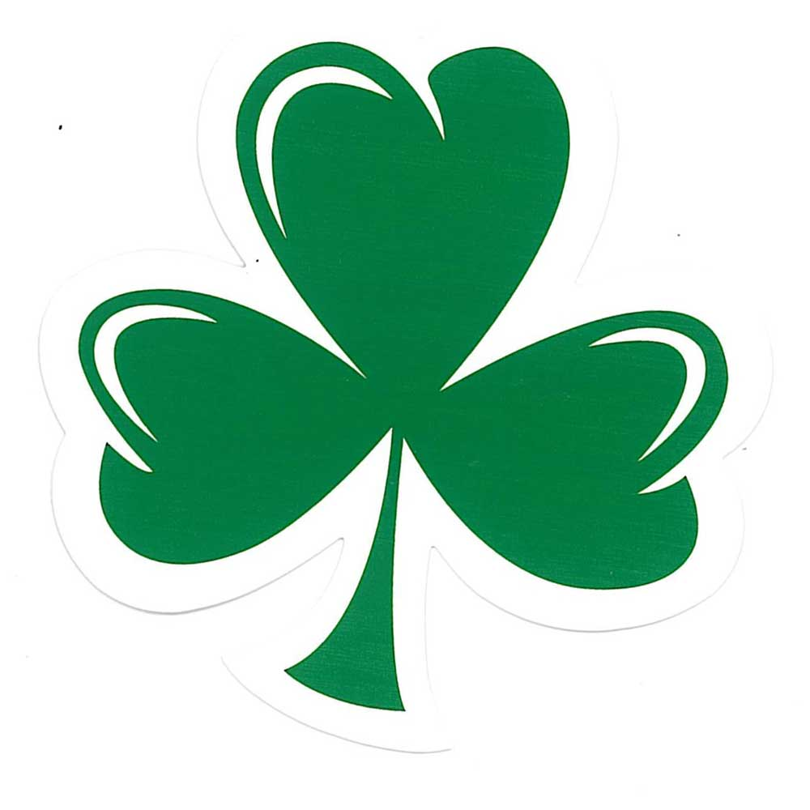
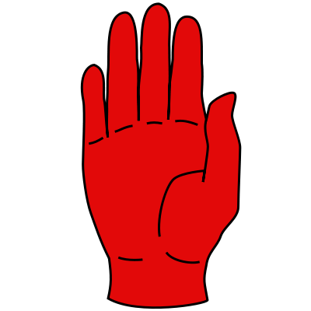
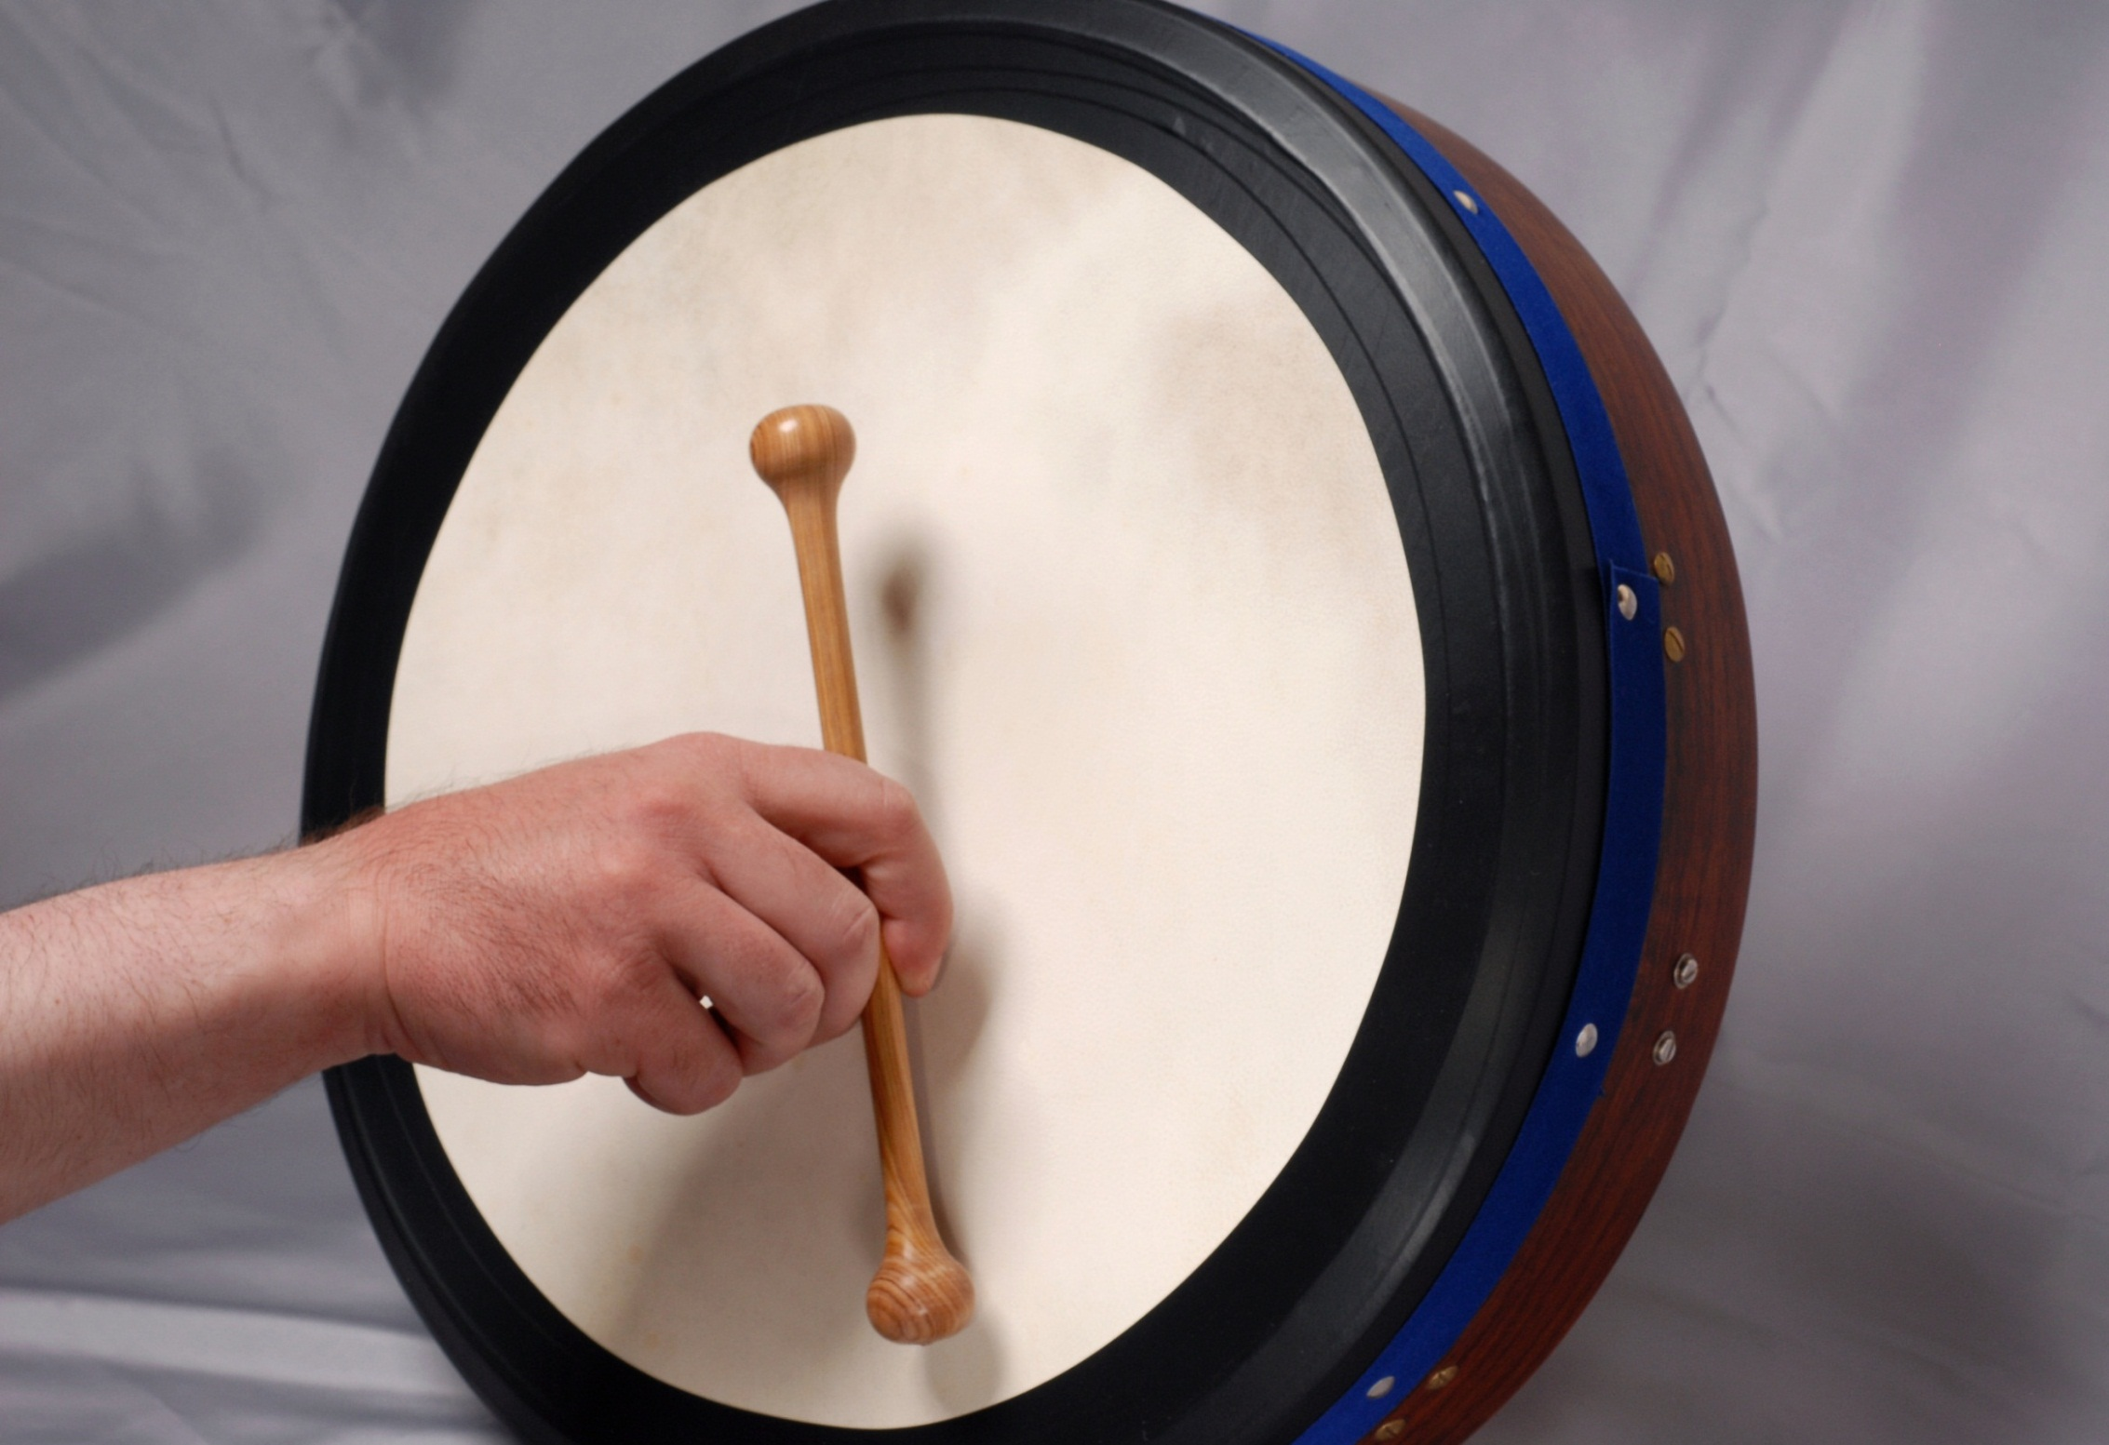
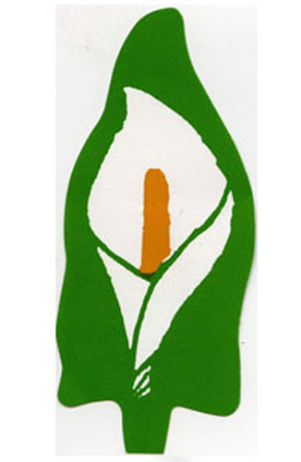
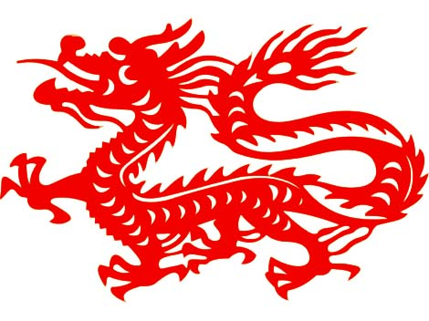

PDMU: Symbols Activity Sheet

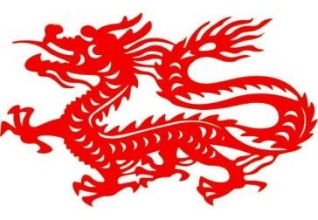
Name: _________________________________
Write down anything you know about this symbol
______________________________________________________________________________________________________________________

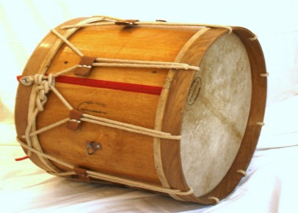
Name: _________________________________
Write down anything you know about this symbol
________________________________________________________________________________________________________________________

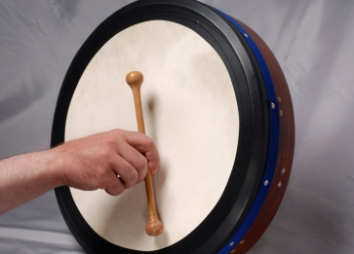
Name: _________________________________
Write down anything you know about this symbol
________________________________________________________________________________________________________________________

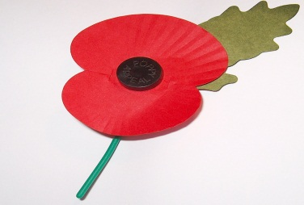
Name: _________________________________
Write down anything you know about this symbol
______________________________________________________________________________________________________________________

Name: _________________________________
Write down anything you know about this symbol
____________________________________________________________________________________________________________________________

Name: _________________________________
Write down anything you know about this symbol
__________________________________________________________________________________________________________________________

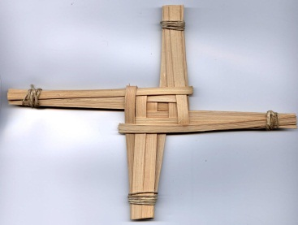
Name: _________________________________
Write down anything you know about this symbol
______________________________________________________________________________________________________________________

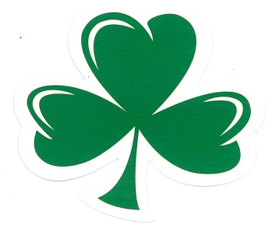
Name: _________________________________
Write down anything you know about this symbol
______________________________________________________________________________________________________________________
Information on Symbols
Symbol | Information
Name: Chinese Dragon

Information: Many years ago the Dragon was a symbol for the Emperor of China. It is used as a symbol for the Chinese culture. Sometimes Chinese people will use the term “Descendants of the Dragon” as a sign of their Chinese ethnic identity.

Name: The Lambeg Drum

Information: The Lambeg Drum is a large drum which makes its sound by being hit with Malacca canes. It is traditionally played in bands that march with the Orange Order. The drum is one of the loudest acoustic instruments in the world along with the bagpipes.
Name: The Bodhrán Drum

Information: The Bodhrán Drum is an Irish frame drum. The word Bodhrán is an Irish word that has been said to mean a drum tambourine. It is made from a circular frame and a stretched goat’s skin and is often played in Irish Traditional Music. It is also widely used in Celtic music outside of Ireland.

Name: The Poppy

Information: The Poppy has been used since 1920 to remember soldiers who have died in war. They were first used by American to remember those who had died in World War 1, but then other countries followed adopting the symbol too.
In Northern Ireland most Irish nationalists and Irish Catholics don’t wear the poppy. Various reasons are put forward one being that it is due to its association with the British Army. There has also been controversy over their introduction to the world of sport.
Name: The Easter Lily

Information: The Easter Lily is a badge worn at Easter by Irish republicans as symbol of remembrance for Irish republican combatants who died during or were executed after the 1916 Easter Rising. A common metal version of the badge uses the colors of the Irish Tricolour Flag.
Name: The Red Hand of Ulster

Information: The Red Hand of Ulster is a symbol used in heraldry (artwork of Coats of Arms) to denote the Irish province of Ulster. The symbol belonged to the O’Neill clan who were a prominent family in ancient Ireland. Legend has it that the symbol of the Red Hand comes from a race to conquer Ireland thousands of years ago. Heremon O’Neill racing a rival chieftain for possession of Ireland became the first man to touch its soil by cutting off his own hand and hurling it ashore!
His sacrifice made Heremon the first king of Ulster! 1015 B.C.

Due to its roots in Gaelic Irish history, the Red Hand has been seen as a cross community symbol having been used by both nationalist and loyalist groups. However, having being used on the Ulster Covenant (1912), in the coat of arms of the Government of Northern Ireland (1924) and more recently within loyalist organisations, has led to the misconception that it is solely a loyalist symbol.

Name: St Brigid’s Cross
Information: St Brigid’s Cross is an Irish symbol. Though a Christian symbol, it possibly derives from the pagan sun wheel. It is usually made from rushes or, less often, straw. It comprises a woven square in the center and four radials tied at the ends.
St. Brigid's cross symbolises the beginning of Spring. In Ireland the official beginning of Spring is February 1st.
These crosses are hung by doors to protect houses from Fire and Evil. Strangely they are made from rushes, not the most fireproof material!
St.Brigid one of the few female saints! She is also commonly known as Bridey. St. Brigid was born near Dundalk in 453ad and was important in spreading Christianity in Ireland.
Legend has it that whilst her father was ill, she was sat by him and to pass the time she gathered rushes and started making these crosses. That is why today we call them St. Brigid's crosses! St. Brigid died on February 1st and that is how we remember it today!
Name: The Shamrock
Information: The shamrock is a three-leaved old white clover. It is known as a symbol of Ireland, with St. Patrick having used it as a metaphor for the Christian Trinity, according to legend. The name shamrock is derived from Irish seamróg, which is the diminutive version of the Irish word for clover (seamair).

