Flag Information Sheet

Flag | Information
Name: St Patrick’s Saltire or The Cross of St Patrick

Description: A red saltire (also described as a diagonal cross) on a white field.

The St Patrick’s Saltire is named after St Patrick, the patron saint of Ireland.
The red saltire from this flag appears as part of the Union Flag.
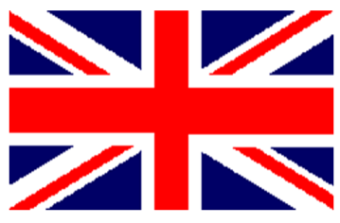 | Name: The Union Flag  Description: The Union Flag brings together three flags:  - The Flag of England, also known as St George’s Cross: A red cross on a while background  - The Flag of Scotland, also known as St Andrew’s Cross: A white diagonal cross on a blue background  - The St Patrick’s Cross, representing Ireland: A red diagonal cross on a white background.  It uses the red cross of St George, the red saltire of St Patrick and the flag of Scotland to make the Union Flag. The design of the flag was made in 1801.  The Union Flag, is used to represent the United Kingdom of Great Britain and Northern Ireland.  The union flag is only called the ‘Union Jack’ when flown at sea.
Name: The Tricolour

Description: The Tricolour has three vertical bands of green, white and orange. The green band is where the flag is flown from. The colours in the flag are there for representation; green for the Catholic population and orange for the Protestant population of the island of Ireland. The white band in the middle represents the hope of lasting peace.

The Tricolour was originally designed to represent the whole of Ireland, but is currently used as the flag for the Republic of Ireland.

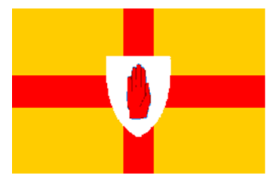 | Name: The Flag of Ulster  Description: The Flag of Ulster has a gold background featuring a red cross with the symbol of the Red Hand of Ulster.  The flag is composed of two symbols which represent two ancient families from Ulster. The gold background and red cross came from the coat of arms of the Burkes and the Red Hand from the O’Neill family.  Legend has it that the symbol of the Red Hand comes from a race to conquer Ireland thousands of years ago. Heremon O’Neill racing a rival chieftain for possession of Ireland became the first man to touch its soil by cutting off his own hand and hurling it ashore!  His sacrifice made Heremon the first king of Ulster in 1015 B.C.  The Flag of Ulster is used to represent the province of Ulster, which is one of the four provinces of Ireland.
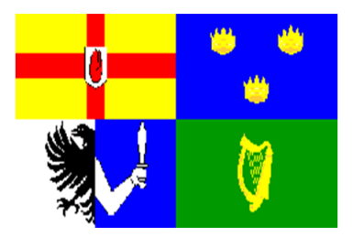 | Name: The Four Provinces of Ireland  Description: Each flag from the four provinces of Ireland are brought together to form the one flag. The four provinces are known as Ulster, Munster, Leinster and Connact. Top left is Ulster, top right is Munster, bottom left is Connact and bottom right is Leinster.
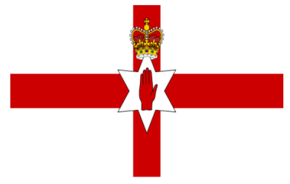 | Name: The Ulster Banner  Description: The Ulster Banner is composed of a red cross on a white field, the Red Hand of Ulster on a six pointed star and a crown at the top of the star.  It is based on the English Flag and the Flag of Ulster with the addition of the six pointed star to represent the six counties of Northern Ireland and the crown on top for the British Monarchy.  It was formerly the flag for the Government of Northern Ireland, but it no longer has any status. It is sometimes used at sporting events to represent Northern Ireland.
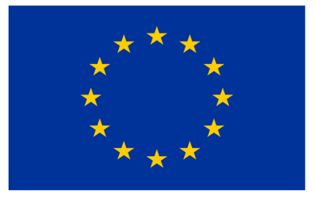 | Name: The Flag of Europe  Description: The European flag has a background of Azure blue with twelve, five pointed golden stars formed into a circle.  It is used to represent the council of Europe and the European Union. The number of stars is based on the fact that twelve is seen as a symbol of perfection and completeness, and does not represent the number of countries in the European Union.

