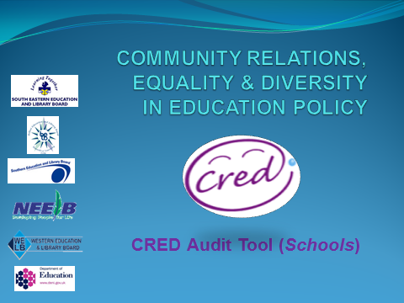
The following indicators of effective performance, based on ESaGS Policy characteristics and identified in DE’s CRED Guidance pp 22-24. Schools may choose to use the alternative Quality Indicator Framework identified in Annex 3 of the Guidance, or alternatively, to develop their own audit tool based on relevant quality indicators identified in ETI’s Together Towards Improvement’.
Child Centred Provision
INDICATORS OF EFFECTIVE PERFORMANCE | SCORE | EVIDENCE | AREA FOR DEVELOPMENT
- Inclusion of CRED principles and aims should feature in School Development Plan.

- A whole school approach is recommended whereby all staff and young people are involved in learning about CRED.

- Within the school ethos/prospectus it should be visible that there is an acceptance of difference and a valuing of diversity.

- Staff recognise the importance of modelling appropriate use of language and behaviour and demonstrating this.

- The school’s approach to CRED implementation reflects the needs of all children.

- Schools are sensitive to and welcoming of the diverse identities of all members of the school community.

- There is a commitment to involve young people in discussions and decisions.

- Encourage children and young people to actively engage with other schools and other communities of different backgrounds and traditions

- Schools should be aware and encouraging of deepening emotional intelligence in their relationships and view of themselves.

- The development of a meaningful school council would be viewed as an essential part of real delivery of child centred provision including issues of rights, equality, democracy and pupil voice.

High Quality Learning and Teaching
INDICATORS OF EFFECTIVE PERFORMANCE | SCORE | EVIDENCE | AREA FOR DEVELOPMENT
- Curriculum planning includes provision for learning about the aims of CRED.

- There should be a process of plan, do, review as in other areas of the curriculum to allow for continuous improvement.

- Teachers reflect on their own work and the outcomes of individual children and young people.

- There is evidence of critical reflection by staff and young people.

- All staff and young people have opportunities to engage in CRED initiatives if possible.

- Young people where possible are involved in making choices which have a positive impact on their learning.

- Teachers should, in line with the statutory requirements of the curriculum, engage with the more challenging aspects of PDMU/Citizenship.

- Teachers should be supported to engage with controversial and sensitive issues.

- Opportunities are given across the curriculum to promote shared values and to help young people to value differences and to challenge prejudice, discrimination and stereotyping.

- Promote an emphasis and understanding of human rights and equality within the UNCRC.

Effective Leadership
INDICATORS OF EFFECTIVE PERFORMANCE | SCORE | EVIDENCE | AREA FOR DEVELOPMENT
- Staff and management have access to appropriate training opportunities in CRED.

- Staff have management support to initiate and sustain CRED practice.

- Support of Board of Governors/Management Committees in following the main principles of CRED.

- Resources are managed properly and effectively, with appropriate arrangements in place for financial management.

- School leadership demonstrates clear vision and commitment to CRED policy and practice.

- There is a promotion of an inclusive ethos within the school.

- There is a commitment to planning, monitoring and evaluating and time given to allow this to be meaningful.

- Engagement with external agencies (such as ETI, ELBs) in relation to monitoring and evaluation.

A School Connected to its Local Community
INDICATORS OF EFFECTIVE PERFORMANCE | SCORE | EVIDENCE | AREA FOR DEVELOPMENT
- Parents, carers and the wider local community are informed about the organisation’s commitment to CRED.

- Parents, carers and the wider community are given the opportunity to engage with members of a different tradition/community.

- Appropriate local connections are sought where possible and relationships developed.

- The school uses its involvement in other programmes to further support the aims of CRED.

- Explore/encourage opportunities for young people to engage with others from different backgrounds/traditions and build positive relationships.

