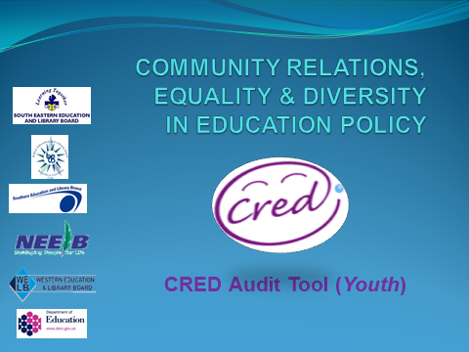
The following indicators of effective performance are identified in DE’s CRED Guidance pp 33-35. Youth Groups may choose to use the alternative Quality Indicator Framework identified in Annex 3 of the Guidance.
Developing Youth Work Practice
INDICATORS OF EFFECTIVE PERFORMANCE | SCORE | EVIDENCE | AREA FOR DEVELOPMENT
- Programme planning includes provision for learning about the aims of CRED.

- A curriculum and programme development cycle is applied to promote continuous improvement.

- Youth workers reflect on their own work and the outcomes for individual young people.

- There is evidence of critical reflection by youth workers and young people.

- All youth workers and young people have opportunities to engage in CRED initiatives.

- Young people are involved in making choices which have a positive impact on their experiences.

- Practice is underpinned by participation principles.

- Youth workers are appropriately trained and confident in dealing with controversial and sensitive issues.

- Opportunities are given throughout programme delivery to promote shared values and to help young people to value differences and to challenge prejudice, discrimination and stereotyping.

- Opportunities are provided to promote an understanding of equality, human rights and the UNCRC. The unit/local group provides opportunities for young people to engage with others from different traditions and communities, and build positive relationships.

- There are opportunities to promote and celebrate CRED work within the community.

Developing People
INDICATORS OF EFFECTIVE PERFORMANCE | SCORE | EVIDENCE | AREA FOR DEVELOPMENT
- Management, staff and volunteers have access to appropriate training opportunities in CRED.

- Staff and volunteers have the support of management/advisory committees to initiate and sustain CRED practice.

- Resources are managed properly and effectively, including financial management arrangements.

- The leadership of the agency/unit demonstrate clear commitment to CRED policy and practice.

- There is a commitment to planning, monitoring and evaluating the work of the agency /unit and time given to that.

- There is engagement with external agencies (such as ETI, ELBs) in relation to monitoring and evaluation. Parents, carers and the wider local community are informed about the units/local groups commitment to CRED.

- Parents, carers and the wider community are given opportunities to engage with others from different traditions and communities.

Developing the Organisation
INDICATORS OF EFFECTIVE PERFORMANCE | SCORE | EVIDENCE | AREA FOR DEVELOPMENT
- The inclusion of CRED in the Service Level agreement.

- A whole organisational approach is evident – all staff, volunteers and young people involved in learning about CRED.

- The unit/local group uses its involvement in other programmes to further support the aims of CRED.

- Umbrella/regional bodies support units and local groups to establish effective networks within their local communities.

- Units/local groups develop effective networks to ensure appropriate local connections.

- There is a visible commitment to acceptance and understanding of others, inclusion and the promotion of the EDI principles.

- Staff and volunteers recognise the importance of modelling appropriate attitudes, language and behaviour and demonstrating these.

- The work of the organisation takes account of the needs of all children and young people.

- Youth work settings are sensitive to the diverse identities of all members of the community.

- There is a commitment to involve young people in discussions and decision making.

